Customer Churn Analysis
Stage 2 Report: Data Preparation and Clustering Analysis

Project Title
Customer Churn Analysis for a Telecommunications Company

Submitted By Team Members:
Simranjeet Kaur
Abhinaya Ginjipalli
Akhil Ravikumar Wakde
Praveen Lakshan Gunaratne
Sonam Galey

Course / Module
Data Analytics Project

Project Stage
Stage 2 – Data Preparation and Modeling

Table of Contents
1. Introduction 3
2. Data Preparation 3
2.1 Initial Data Exploration 3
2.2 Missing Data Handling and Data Integrity 3
2.3 Categorical Encoding 4
2.4 Feature Engineering Considerations 4
2.5 Feature Scaling and Normalization 5
2.7 Outcome of Data Preparation 5
3. Clustering Analysis 6
3.1 Determining the Optimal Number of Clusters 6
3.2 K-Means Model Training 6
3.3 Cluster Visualization Using PCA 7
3.4 Cluster Characteristics and Observations 8
3.5 Outcome of Clustering Analysis 8
4. Cluster Insights and Business Interpretation 9
4.1 Cluster-Level Behavioural Patterns 9
4.2 Churn Risk Across Customer Segments 9
4.3 Business Interpretation of Customer Segments 10
4.4 Strategic Value of Segmentation 11
5. Key Findings 12
6. Limitations and Challenges 13
7. Conclusion 14

1. Introduction
Stage 2 of the Customer Churn Analysis project was aimed at preparing the telecommunications customer dataset to be used in machine learning and to conduct a clustering analysis to discover meaningful customer segments. The data preparation process guarantees the quality of data, its consistency, and compatibility with the analysis models, whereas the data clustering process tends to reveal the underlying patterns in the customer behaviour that can be utilised in the development of the retention strategies.
It was analyzed with Python and major libraries of data science, such as Pandas, NumPy, Matplotlib, and Scikit-learn.

2. Data Preparation
The preparation of the data was done to make the dataset consistent, machine-learning ready, and good enough to perform clustering and predictive modeling. The step involved a check on the quality of data, data transformation (categorical variables), feature scaling, and the creation of organized datasets to be used in subsequent analysis.

2.1 Initial Data Exploration
The dataset included the customer data pertaining to demographic characteristics, service subscriptions, type of contract and churn status. To get a feel of data structure and types of features, a preliminary exploratory analysis was conducted with the help of Pandas functions head, info, and describe.
Key observations from the initial exploration included:
- Total records: 7043 customers
- Total features: 10
- Target variable: Churn
- Data types included numerical and categorical attributes.
- Variables such as contract type, gender, payment methods, and internet service were categorical in nature.
Understanding data types at this stage helped determine the preprocessing techniques required for machine learning compatibility.

2.2 Missing Data Handling and Data Integrity
The null-value analysis was performed to check whether the columns were entirely checked to ensure no missing values. The results indicated that:
- None of the data points were missing in the data set.
Since it was ensured that the data was complete, no imputation methods were needed. This guaranteed that the preprocessing was only concerned with transformation not correction hence data integrity..
Additional validation steps ensured:
- No duplicated rows were identified.
- Feature values remained consistent with expected categories.
- Target variable labels were clearly defined as Yes/No.

2.3 Categorical Encoding
Machine learning algorithms require numeric inputs; therefore, categorical variables were transformed into numerical representations.
The following preprocessing steps were applied:
- The target variable Churn was converted into binary format:
  - Yes → 1
  - No → 0
- Input categorical variables were encoded using one-hot encoding.
The reason why it was selected to use one-hot encoding is that:
- It does not have artificial ordinal relationships between categories.
- It does not lose interpretability of customer attributes.
- It can be used in clustering and in neural network modeling.
In the process of encoding several new binary features were generated (e.g., type of contract and type of internet service). The resultant logical outputs of the encoding process were then translated into numerical form (0/1) in order to be completely compatible with analytical models..

2.4 Feature Engineering Considerations
New engineered features were not introduced at this point but close manipulation of the variables introduced prior to this point ensured that:
- Demographic features of customers,
- Preferences in service subscription,
- and billing attributes
had all a numerically represented representation and could be used in distance-based clustering.
The preprocessing pipeline was used to provide uniform feature representation of all samples..

2.5 Feature Scaling and Normalization
StandardScaler of Scikit-learn was used to perform feature scaling.
This was important since K-Means clustering is based on the calculation of Euclidean distance. Without scaling, those features that have bigger numeric spreads (e.g., tenure or monthly charges) would completely affect clustering behaviour and prejudice outcomes.
The standardization changed every feature to:
- Mean = 0
- Standard deviation = 1
Scaling had the following benefits:
- Even-handed contribution of features.
- Better clustering algorithms convergence.
- Enhanced stability in subsequent ANN modeling.
2.6 Train-Test Data Splitting
The preprocessed dataset was divided into training and testing subsets to support reliable model development and validation.
Configuration used:
- Training set: 80%
- Testing set: 20%
- Stratified sampling based on churn
Stratification ensured that churn distribution remained consistent between datasets, reducing sampling bias and improving the reliability of future predictive modeling in Stage 3.
The resulting outputs included:
- X_train and X_test feature sets
- y_train and y_test target labels
- Scaled versions of training and testing features

2.7 Outcome of Data Preparation
By the end of this stage:
- All features were numerical and model-ready.
- Data was standardized for clustering analysis.
- Structured training and testing datasets were created.
- The dataset was fully prepared for unsupervised segmentation using K-Means clustering.

3. Clustering Analysis
Clustering analysis was done to draw natural groups of customers according to behavioural and service related attributes in the customer base. Using the segmentation of customers into small groups, the analysis focused on identifying trends linked with client features and their possible churn behaviour. K-Means clustering was chosen because it is efficient, its interpretation is easy to understand, and it is used when the data is structured (done in numerical form).

3.1 Determining the Optimal Number of Clusters
The Elbow Method was used to determine the number of customer segments that was appropriate. Numerous K-Means models were fitted under different cluster sizes and the Within-Cluster Sum of Squares (WCSS) were checked.
The curve obtained exhibited a significant decrease in inertia to a point after which, it improved successively smaller. This slope was a sign of the point of diminishing returns.
K = 5 was found to identify the elbow, indicating that five clusters provided a tradeoff between the segmentation detail and model simplicity.
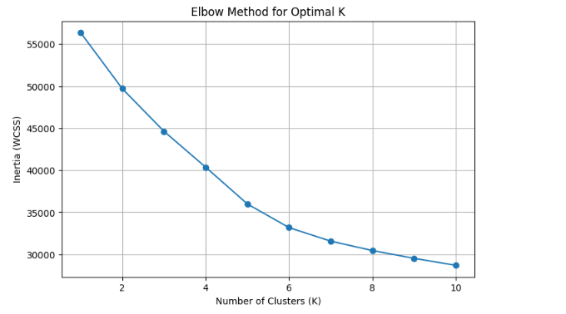
Figure 1: Elbow Method showing the optimal number of clusters selected at K = 5.

3.2 K-Means Model Training
Once the best number of clusters has been chosen, a K-Means model was trained on the scaled training data. Scaling was used so that the features used in the distance calculations were equally important so that the variables with a bigger range do not play a bigger role in the formation of a cluster.
Every customer record was given a cluster name denoting the belonging to one of five customer segments. Such labels made it possible to further analyse the behavioural patterns within groups and formed the basis of understanding customer profiles.

3.3 Cluster Visualization Using PCA
Direct visualisation cannot be used in high-dimensional space since the dataset will have many features. Thus, data reduction to two dimensions by Principal Component Analysis (PCA) was applied that maintained most of the variance.
The PCA projection gave a visual depiction of the clusters, based on the ability to examine the separation and overlap of clusters. It can be observed that there are separate segments of customers, which justifies the appropriateness of the clustering solution.
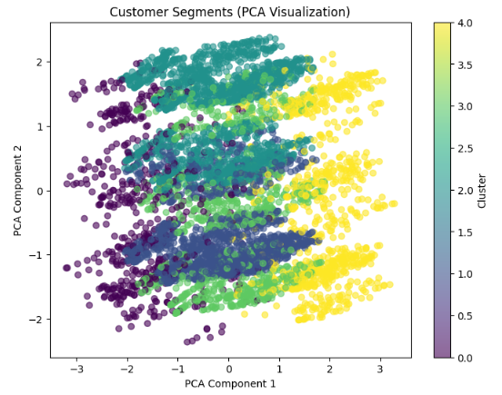
Figure 2: PCA-based visualization of customer clusters generated by K-Means.

3.4 Cluster Characteristics and Observations
Cluster level analysis was done by determining the average values of features and the churn rates of each segment. This aided in the conversion of numerical clusters into valuable groups of customers.
Key observations include:
- The customers were segmented into customers who had various tenure lengths and spending behaviors.
- Certain clusters had features linked to increase in churn risks especially shorter terms and increased monthly fees.
- Other groups seemed to be more secure, as they were comprised of long term customers who had a lower churn rate.
The implications of these differences are that customer behaviour is heterogeneous and that instead of implementing uniform retention strategies on the entire customer base, an organization should implement different retention strategies to different segments of customers..
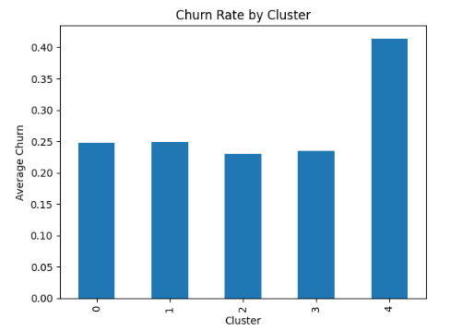

3.5 Outcome of Clustering Analysis
The clustering activity was effective to divide customers into five significant groups. The findings show that customer behaviour differs on various levels, such as the period of subscription and billing. These findings offer an effective analytical base to business strategies of targeting and predictive modeling of the Stage 3.

4. Cluster Insights and Business Interpretation
This section aims at converting the clustering findings into a business understandable finding that will help in customer retention practices. Using average feature values and churn characteristics of each cluster, different profiles of customers were observed.
The cluster analysis revealed that customers are highly differentiated, based on elements like tenure, usage of services and monthly fees among others. These variations suggest that churn risk is not homogenous, and the particular spheres of customers need to be addressed.

4.1 Cluster-Level Behavioural Patterns
Cluster summary analysis indicated obvious difference between customer segments. Certain groups were made up of customers with longer duration of subscriptions and more predictable behavioural patterns and others with behavioural traits that are traditionally related to increased churn risk.
Such general observations as:
- Customers with lower tenure would be found more in the riskier clusters.
- An increase in monthly fees was often linked to the risks of churn.
- More stable clusters had general concentration of the long-term contract customers.
Such trends indicate that the cost of the service, the form of the contract and the stage of the lifecycle of the customers have a strong impact on the segmentation outcomes..

4.2 Churn Risk Across Customer Segments
Comparison of the churn rates across clusters also gave more information on what segments of customers need a proactive intervention.
It was demonstrated that:
- Some of the clusters also showed significantly increased average churn rates.
- Newer, less-tenured customers who were often high-risk clusters characterized high-risk clusters.
- The less risky groups consisted of subscribers who used the services on a more regular basis and in the long term.
It shows the relevance of engaging customers and reinforcing the value at a young stage at the beginning of the subscription term..
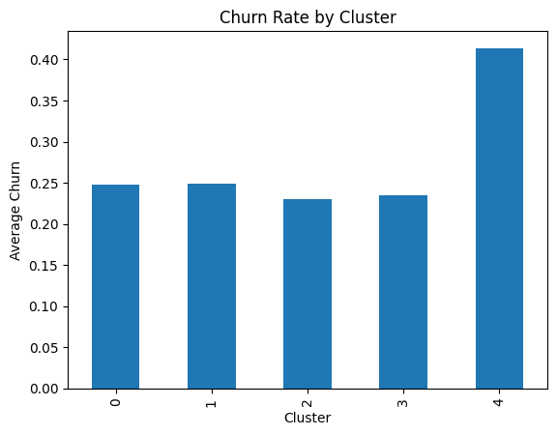
Figure 3: Comparison of churn rates across customer clusters.

4.3 Business Interpretation of Customer Segments
The finding of the clustering indicates that customers are not a piece of homogenous population but a cluster of behaviour groups. This facilitates decision making based on segmentation, as far as business is concerned.
Examples of strategic interpretation are:
- The retention campaigns, support during the onboarding, or the promotion packages might be necessary in high-churn clusters.
- Medium-risk groups can be offered customised service suggestions as a way of enhancing engagement.
- Stable clusters are the loyal customers and can be selected in the long-term loyalty program or upselling opportunities.
Identifying such groups early, the organisation will have a chance to spend resources more productively and enhance the overall customer lifetime value..

4.4 Strategic Value of Segmentation
Customer segmentation gives the basis of retention strategy development with data. Telecoms companies are able to customise interventions of particular behavioural patterns instead of using universal marketing or service policies.
Some of the major results of the segmentation process are:
- Better knowledge of customer diversity.
- Recognition of risky groups of customers.
- Unambiguous data to be used in future predictive modeling.
The insights also relate well with the project aims, which is to prepare the dataset ready to predict the churn in Stage 3..

5. Key Findings
The data preparation and clustering analysis resulted into some significant findings on customer behaviour and patterns of segmentation. The preprocessing pipeline was able to convert the raw data into a machine-learning-ready form that is structured, which is capable of doing a reliable clustering analysis.
In Stage 2, the following key findings were made:
- The data did not need much cleaning up and instead, transformation and readiness to model could be focused on.
- Scaling of features contributed greatly to the compatibility with distance based clustering algorithms.
- The Elbow Method came up with five significant customer segments.
- Clustering also showed visible behavioural variations across customers.
- The churn behaviour was not homogeneous with different clusters meaning that the level of customer risk varies depending on subscription and usage habits.
All in all, the analysis indicates that customer segmentation is capable of revealing actionable insights, which are not observable when analysing the customer base as a single group.

6. Limitations and Challenges
Although the clustering analysis had meaningful results in segmentation, there are a number of limitations that need to be mentioned.
First, K-Means clustering is unsupervised and is not explicitly aimed at churn prediction. Consequently, feature similarity is used to form clusters and not the results of churn.
Second, PCA visualisation lowers the number of dimensions to two values and simplifies the interpretation, but this can be inaccurate at fully representing the complex relationships present in the dataset.
Additionally:
- Analysis was based on available features in the dataset.
- The external factors like customer satisfaction or service quality metrics were not used.
- Cluster interpretation is based on aggregate averages and this can not be a comprehensive way of describing individual customer behaviour.
These shortcomings emphasize ways of developing better stages of the same by means of more sophisticated modeling and more features..

7. Conclusion
Stage 2 of Customer Churn Analysis project was able to prepare a database of telecommunications and use clustering methods to determine various customer groups. Preprocessing of data has guaranteed consistency, numerical and scaling through features, which form a strong basis of analysis.
The clustering process had identified five meaningful customer groups and showed differences in behavioural patterns, spending characteristics and churn tendencies. These lessons indicate that the customer groups are heterogeneous and need specific analytical methods but not general ones.
The results of this step form a good input to the Stage 3 wherein the predictive modeling methods will be applied to predict customer churn and help in the formulation of data-oriented retention policies.

